ASSIGNMENT NO. 3
AIM: Design a distributed application using RPC for remote computation where client submits an integer value to the server and server calculates factorial and returns the result to the client program.

PRE REQUSITE: Concept of Client Server Communication & Working of Conventional
Procedures.

THEORY:
RPC Introduction:
Local procedure call (Calling procedure and Called procedure are in the same
process)
Many distributed systems have been based on explicit message exchange between processes. However, the procedures send and receive do not conceal communication, which is important to achieve access transparency in distributed systems. This problem has long been known, but little was done about it until a paper by Birrell and Nelson (1984) introduced a completely different way of han- dling communication. Although the idea is refreshingly simple (once someone has thought of it), the implications are often subtle. In this section we will examine the concept, its implementation, its strengths, and its weaknesses. In a nutshell, what Birrell and Nelson suggested was allowing programs to call procedures located on other machines. When a process on machine A calls a procedure on machine B the calling process on A is suspended, and execution of the called procedure takes place on B. Information can be transported from the caller to the callee in the parameters and can come back in the procedure result. No message passing at all is visible to the programmer. This method is known as Remote Procedure Call, or often just RPC. While the basic idea sounds simple and elegant, subtle problems exist. To start with, because the calling and called procedures run on different machines, they execute in different address spaces, which causes complications. Parameters and results also have to be passed, which can be complicated, especially if the machines are not identical. Finally, both machines can crash and each of the possible failures causes different problems. Still, most of these can be dealt with, and RPC is a widely-used technique that underlies many distributed systems.

How RPC works?
An RPC is analogous to a function call. Like a function call, when an RPC is made, the calling arguments are passed to the remote procedure and the caller waits for a response to be returned from the remote procedure. Figure 32.1 shows the flow of activity that takes place during an RPC call between two networked systems. The client makes a procedure call that sends a request to the server and waits. The thread is blocked from processing until either a reply is received, or it times out. When the request arrives, the server calls a dispatch routine that performs the requested service, and sends the reply to the client. After the RPC call is completed, the client program continues. RPC specifically supports network applications.
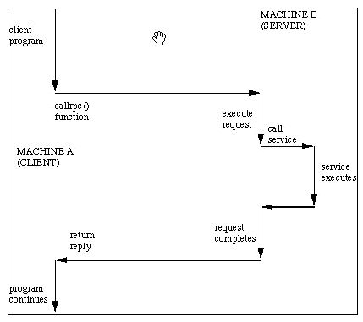
Fig. 32.1 Remote Procedure Calling Mechanism
A remote procedure is uniquely identified by the triple: (program number, version number, procedure number) The program number identifies a group of related remote procedures, each of which has a unique procedure number. A program may consist of one or more versions. Each version consists of a collection of procedures which are available to be called remotely. Version numbers enable multiple versions of an RPC protocol to be available simultaneously. Each version contains a a number of procedures that can be called remotely. Each procedure has a procedure number.

Difference between CORBA, RMI, Sockets and RPC.
RPC | RMI | CORBA
RPC is language neutral | RMI is limited to Java | Services can be written in many different languages executed on many different platforms, and accessed by any language with an interface definition language (IDL) mapping.
RPC supports only primitive data types. programmer must split any compound objects to primitive data types. | RMI allows objects to be passed as arguments and return values. | CORBA supports primitive data types, and a wide range of data structures, as parameters
RPC is hard to program | RMI is easy to program | Some training is still required, and CORBA specifications are still in a state of flux.
RPC is faster than RPC since RPC does not involve execution of java bytecode | RMI is slower than RPC since RMI involves execution of java bytecode | offers greater performance
RPC does not have this capability. | RMI allows usage of design patterns due to the object oriented nature | Supports Design Patterns such as Singleton,Façade etc.
RPC is procedural like in C | RMI is object oriented | CORBA uses an object-oriented model although the systems that use CORBA do not have to be object-oriented. CORBA is an example of the distributed object paradigm.

INPUT:
- Send an integer value through client program as a parameter in RPC to server program
OUTPUT:
- The server contains the RPC procedures that returns the result like factorial of integer value to the client.
OPERATIONAL STEPS REQUIRED: ----
Implementation of an application using SUN RPC ( rpcgen)
Following steps are required:
1. Create the IDL
2. Generate sample client and server code
3. First test of the client and server
4. Getting the server to do some work
5. Making the client functional
1. Interface Definition Language:
The first step involves defining the interface. This interface is strictly defined using Sun's format for its IDL. An IDL is a file (suffixed with .x) which optionally begins with a bunch of type definitions and then defines the remote procedures. A set of remote procedures are grouped into a version. One or more versions are grouped into a program.
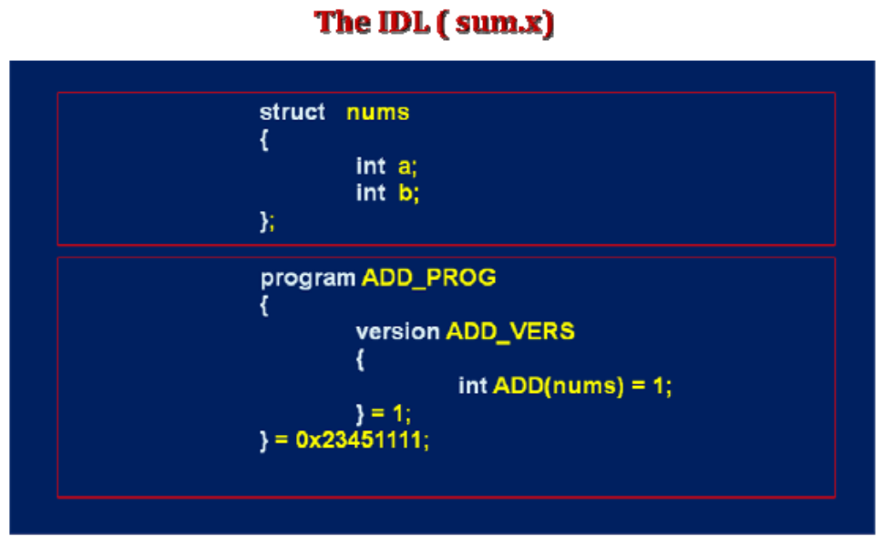

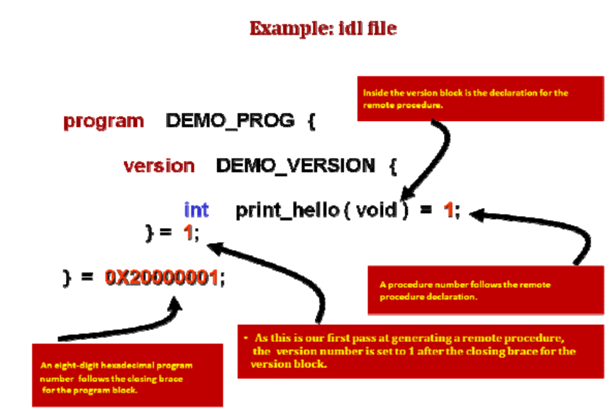

2. Generate sample client and server code
• rpcgen -a -C add.x

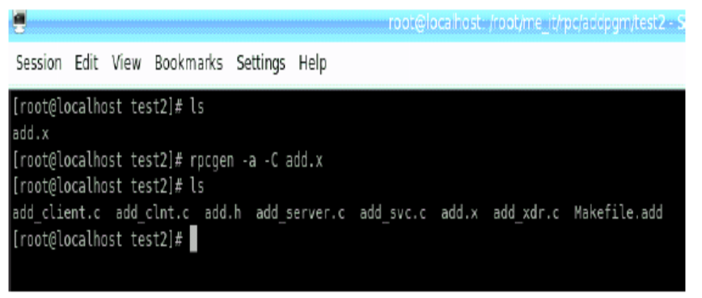

- Makefile
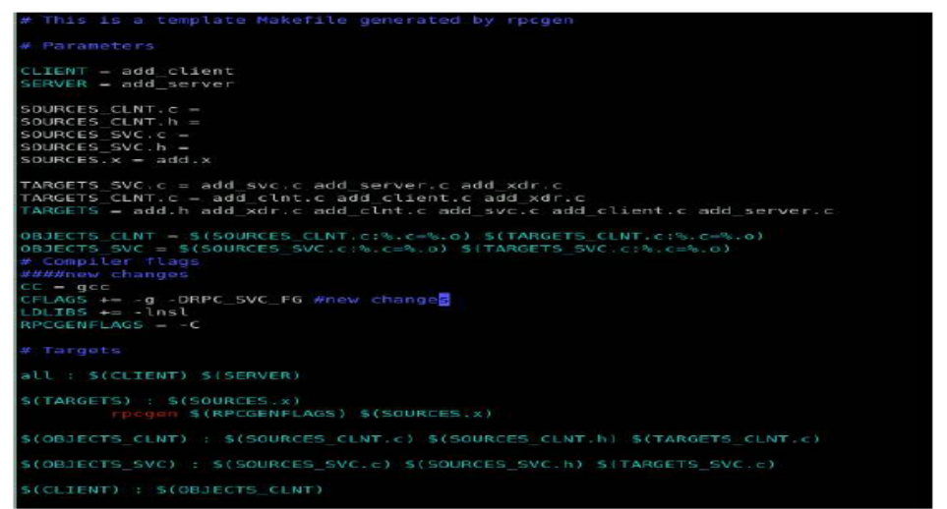

3. First test of the client and server
• The template codes written by rpcgen
• add_client.c
Accepts a single argument on the command line containing the name of the server.
creates an RPC handle to the server process, and calls the add_1 function.
add_server.c
• The server function, contained in add_server.c is a function which does nothing
but contains the comments:
/*
* insert server code here
*/
• We will replace those comments with a single print statement:
printf (“add function called\n“ ) ;
4. Getting the server to do some work
The first parameter of the add_1_svc function is our incoming parameter of type nums.
We will add another print statement after the “add function called\n" one to print the
values of the parameters.

ONC RPC passes an address to the parameter on the client side and the server receives a
local address of the incoming parameter.
ONC RPC passes an address to the parameter on the client side and the server receives a
local address of the incoming parameter. We now add the statement:
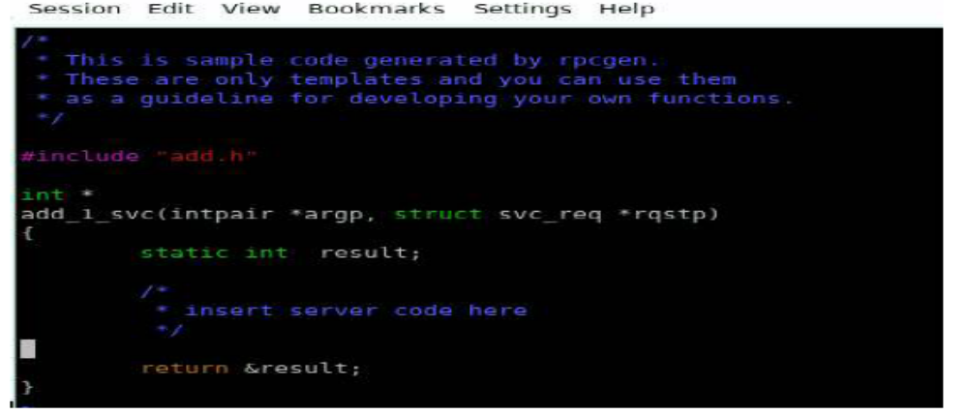
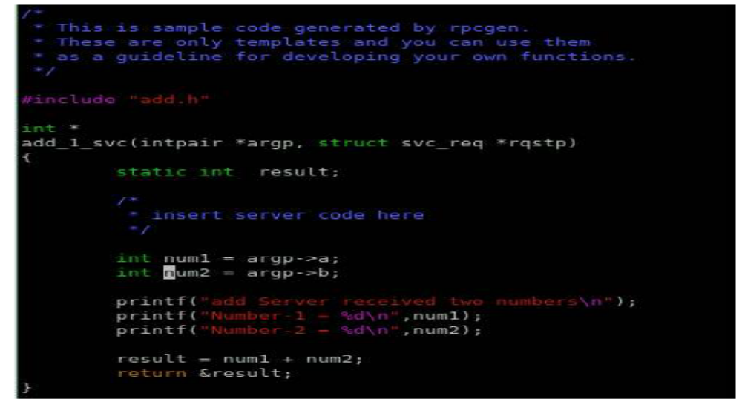

5. Making the client functional
• All we need now to get our program to work is to get the two numbers from the
command line instead of using hard-coded values.
Initialize parameter in client:
Edit add_client.c. Note that the function add_prog_1 defines a variable add_1_arg. This argument is passed as a parameter to the remote procedure call a few lines later with the call: result_1 = add_1(&add_1_arg, clnt); Before calling this function, we will initialize add_1_arg to contain the numbers 11 and 22.
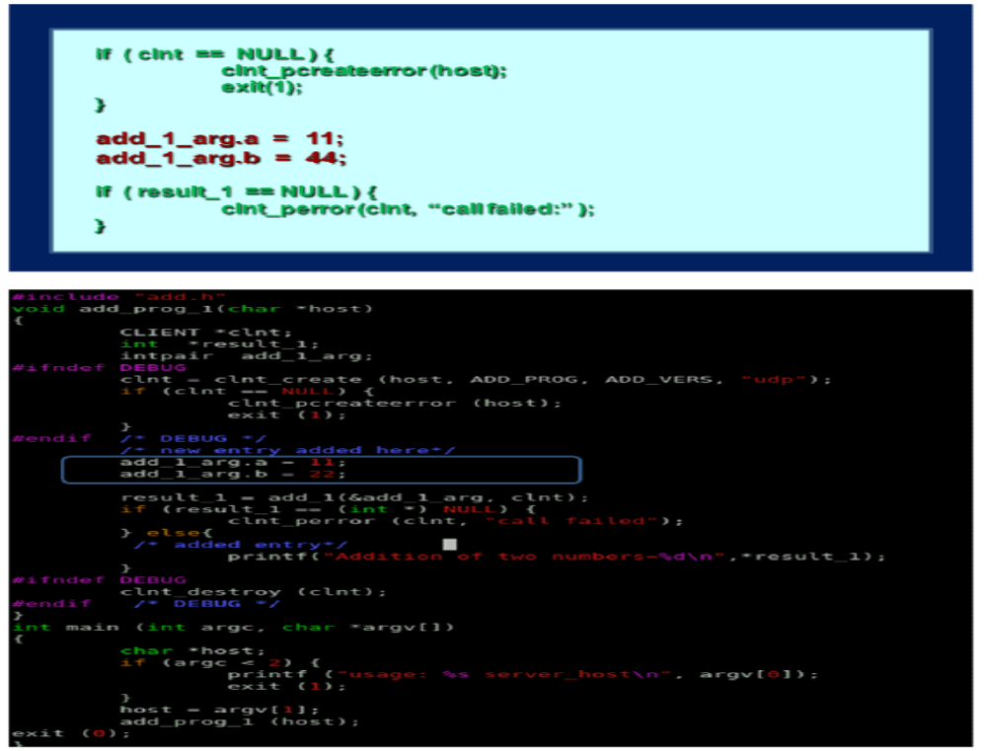

6. Compile and execute.
Compile (make) again, run the server, and run the client.
For example: $. /add_client localhost 5 7
should yield: result = 12
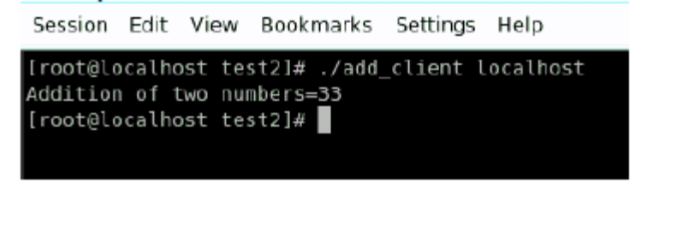

ADVANTAGES and DISADVANTAGES OF RPC:
Advantages
- Server independent.
- Process-oriented and thread oriented models supported by RPC.
- The development of distributed systems is simple because it uses straightforward semantics and easier.
- Like the common communications between the portions of an application, the development of the procedures for the remote calls is quite general.
- The procedure calls preserves the business logics which is apt for the application.
- The code re-writing / re-developing effort is minimized.
- Enables the usage of the applications used in the distributed environment, not only in the local environment.
Disadvantages
- Context switching increases scheduling costs.
- RPC is not a standard – it is an idea that can be implemented in many ways
- RPC does not solve the most of the distribution creation problems
- RPC is only interaction based. This does not offer any flexibility in terms of hardware architecture.
CONCLUSION:
Thus we have designed a distributed application using RPC for remote computation.

REFERENCES:

FAQ’S:
- What is Remote procedure call? Explain its architecture..
Many distributed systems have been based on explicit message exchange
between processes. However, the procedures send and receive do not conceal
communication, which is important to achieve access transparency in distributed systems.
This problem has long been known, but little was done about it until a
paper by Birrell and Nelson (1984) introduced a completely different way of handling communication. Although the idea is refreshingly simple (once someone has thought of it), the implications are often subtle. In this section we will examine the concept, its implementation, its strengths, and its weaknesses.
In a nutshell, what Birrell and Nelson suggested was allowing programs to
call procedures located on other machines. When a process on machine
A calls a procedure on machine B , the calling process on A is suspended, and execution of the called procedure takes place on B. Information can be transported from the caller to the callee in the parameters and can come back in the procedure result. No message passing at all is visible to the programmer. This method is known as Remote Procedure Call , or often just RPC.
While the basic idea sounds simple and elegant, subtle problems exist. To
start with, because the calling and called procedures run on different machines,
they execute in different address spaces, which causes complications. Parameters and results also have to be passed, which can be complicated, especially if the machines are not identical. Finally, both machines can crash and each of the possible failures causes different problems. Still, most of these can be dealt with, and RPC is a widely-used technique that underlies many distributed systems.

RPC Architecture
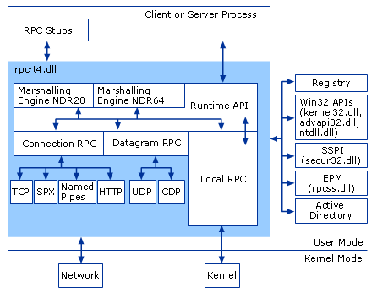
- What is the Stub and Skeleton in RPC?
RMI uses a standard mechanism (employed in RPC systems) for communicating with remote objects: stubs and skeletons. A stub for a remote object acts as a client's local representative or proxy for the remote object. The caller invokes a method on the local stub which is responsible for carrying out the method call on the remote object. In RMI, a stub for a remote object implements the same set of remote interfaces that a remote object implements.
When a stub's method is invoked, it does the following:
- initiates a connection with the remote JVM containing the remote object,
- marshals (writes and transmits) the parameters to the remote JVM,
- waits for the result of the method invocation,
- unmarshals (reads) the return value or exception returned, and
- returns the value to the caller.
The stub hides the serialization of parameters and the network-level communication in order to present a simple invocation mechanism to the caller.
In the remote JVM, each remote object may have a corresponding skeleton (in Java 2 platform-only environments, skeletons are not required). The skeleton is responsible for dispatching the call to the actual remote object implementation. When a skeleton receives an incoming method invocation it does the following:
- unmarshals (reads) the parameters for the remote method,
- invokes the method on the actual remote object implementation, and
- marshals (writes and transmits) the result (return value or exception) to the caller.
In the Java 2 SDK, Standard Edition, v1.2 an additional stub protocol was introduced that eliminates the need for skeletons in Java 2 platform-only environments. Instead, generic code is used to carry out the duties performed by skeletons in JDK1.1. Stubs and skeletons are generated by the rmic compiler.
- How parameter passing will be done in RPC?
Parameter Passing
The function of the client stub is to take its parameters, pack them into a mes-
sage, and send them to the server stub. While this sounds straightforward, it is not quite as simple as it at first appears. In this section we will look at some of the issues concerned with parameter passing in RPC systems. Passing Value Parameters Packing parameters into a message is called parameter marshaling .Asa very simple example, consider a remote procedure, add(i, j), that takes two integer parameters I and j and returns their arithmetic sum as a result. (As a practical matter, one would not normally make such a simple procedure remote due to the overhead, but as an example it will do.) The call to add , is shown in the left-hand portion (in the client process) in Fig. 2-3. The client stub takes its two parameters and puts them in a message as indicated. It also puts the name or number of the procedure to be called in the message because the server might support several different calls, and it has to be told which one is required.

Passing Reference Parameters
We now come to a difficult problem: How are pointers, or in general, references passed? The answer is: only with the greatest of difficulty, if at all. Remember that a pointer is meaningful only within the address space of the process in which it is being used. Getting back to our read example discussed earlier, if the second parameter (the address of the buffer) happens to be 1000 on the client, one cannot just pass the number 1000 to the server and expect it to work. Address 1000 on the server might be in the middle of the program text. One solution is just to forbid pointers and reference parameters in general. However, these are so important that this solution is highly undesirable. In fact, it is not necessary either. In the read example, the client stub knows that the second parameter points to an array of characters. Suppose, for the moment, that it also knows how big the array is. One strategy then becomes apparent: copy the array into the message and send it to the server. The server stub can then call the server with a pointer to this array, even though this pointer has a different numerical value than the second parameter of read has. Changes the server makes using the pointer (e.g., storing data into it) directly affect the message buffer inside the
server stub. When the server finishes, the original message can be sent back to the
client stub, which then copies it back to the client. In effect, call-by-reference has
been replaced by copy/restore. Although this is not always identical, it frequently
is good enough. One optimization makes this mechanism twice as efficient. If the stubs know whether the buffer is an input parameter or an output parameter to the server, one of the copies can be eliminated. If the array is input to the server (e.g., in a call to write) it need not be copied back. If it is output, it need not be sent over in the first place.

- What is the Concept of Doors?
The original RPC model assumes that the caller and callee can communicate
only by means of passing messages over a network. In general, this assumption is correct. However, suppose that the client and server reside on the same machine.
Normally, we would make use of the local interprocess communication (IPC)
facilities that the underlying operating system offers to processes running on the same machine. For example, in UNIX such facilities include shared memory, pipes, and message queues (see Stevens, 1999 for a detailed discussion on IPC in UNIX systems).
Local IPC facilities tend to be much more efficient than networking facilities,
even if the latter are used for communication between processes on the same
machine. Consequently, when performance is an issue, different interprocess
communication mechanisms may need to be combined depending on whether or not the processes we are dealing with are located on the same machine.
As a compromise, a few operating systems offer an equivalent of RPCs for
processes that are colocated on the same machine, called doors. A door
is a gen- eric name for a procedure in the address space of a server process that can be called by processes colocated with the server. Doors were originally designed for the Spring operating system (Mitchell et al., 1994), and are described extensively

- Explain various steps in writing a client and a server in DCE RPC?

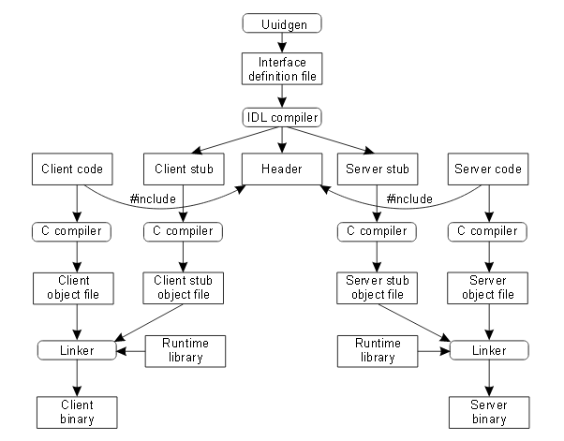

- What is portmapper?
To run any of the software mentioned below you will need to run the program /sbin/portmap. Some Linux distributions already have the code in the /sbin/init.d/ or /etc/rc.d/ files to start up this daemon. All you have to do is to activate it and reboot your Linux machine. Read your Linux Distribution Documentation how to do this.
The RPC portmapper (portmap(8)) is a server that converts RPC program numbers into TCP/IP (or UDP/IP) protocol port numbers. It must be running in order to make RPC calls (which is what the NIS/NIS+ client software does) to RPC servers (like a NIS or NIS+ server) on that machine. When an RPC server is started, it will tell portmap what port number it is listening to, and what RPC program numbers it is prepared to serve. When a client wishes to make an RPC call to a given program number, it will first contact portmap on the server machine to determine the port number where RPC packets should be sent.
Since RPC servers could be started by inetd(8), portmap should be running before inetd is started.

7)Which are the necessary files generated by rpcgen to execute the RPC?
- A header file of definitions common to the server and the client
- A set of XDR routines that translate each data type defined in the header file
- A stub program for the server
- A stub program for the client
- A time-out for servers (optionally)
- C-style arguments passing ANSI C-compliant code (optionally)
- (optionally) dispatch tables that the server can use to check authorizations and then invoke service routines.

8)What are the different data types used in implementation of RPC in SUNRPC?
- int
- unsigned int
- long
- enum
- bool
- float
- double
- typedef
- structure
- fixed array
- string (null terminated char *)

- Explain at least two applications where the RPC mechanism is used.
- Background Intelligent Transfer Service Transfers data between clients and servers in the background.
- COM+ Event System Supports System Event Notification Service (SENS), which provides automatic distribution of events to subscribing Component Object Model (COM) components.
- COM+ System Application Manages the configuration and tracking of COM+-based components.
- Cryptographic Services Provides three management services: Catalog Database Service, which confirms the signatures of Windows files; Protected Root Service, which adds and removes Trusted Root Certification Authority certificates from this computer; and Key Service, which helps enroll this computer for certificates.
- DHCP Server
Performs TCP/IP configuration for DHCP clients, including dynamic assignments of IP addresses, specification of the WINS and DNS servers, and connection–specific Domain Name System (DNS) names.

- Distributed Link Tracking Client
Enables client programs to track linked files that are moved within an NTFS volume to another NTFS volume on the same computer or to an NTFS volume on another computer.

- Distributed Link Tracking Server
Enables the Distributed Link Tracking Client service within the same domain to provide more reliable and efficient maintenance of links within the domain.

- Distributed Link Transaction Coordinator
Coordinates transactions that span multiple resource managers, such as databases, message queues, and file systems.

- DNS Server
Enables DNS clients to resolve DNS names by answering DNS queries and dynamic update requests.

- Error Reporting Service
Collects, stores, and reports unexpected application failures to Microsoft.

- File Replication Service
Allows files to be automatically copied and maintained simultaneously on multiple servers.

- Help and Support
Enables Help and Support Center to run on the computer.

